**Task 1: Check linux installed or not**

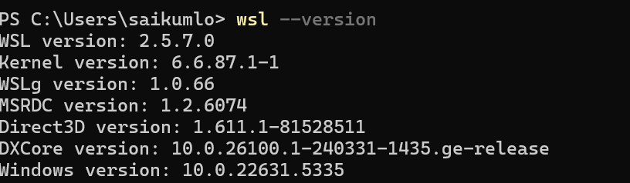

**Task 2: Create a directory Linux**

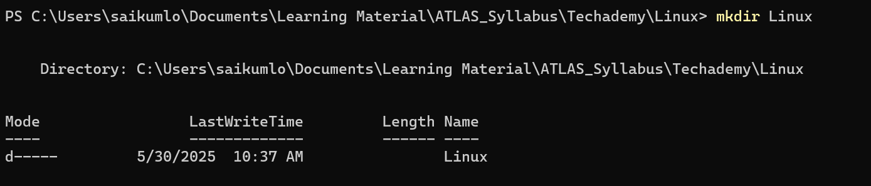

**Task3: Create a file and add content to it**

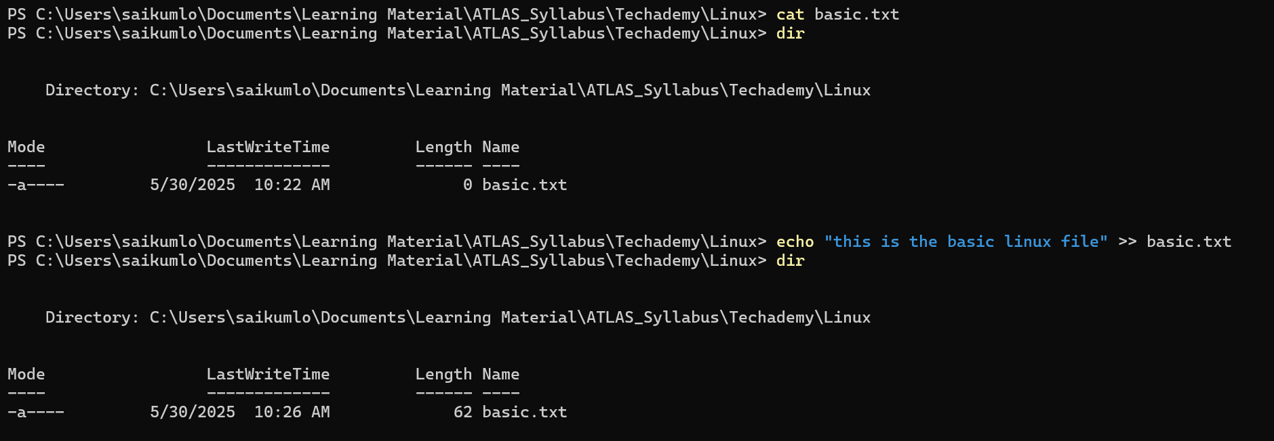

**Task4: Create a dummy folder and delete it**

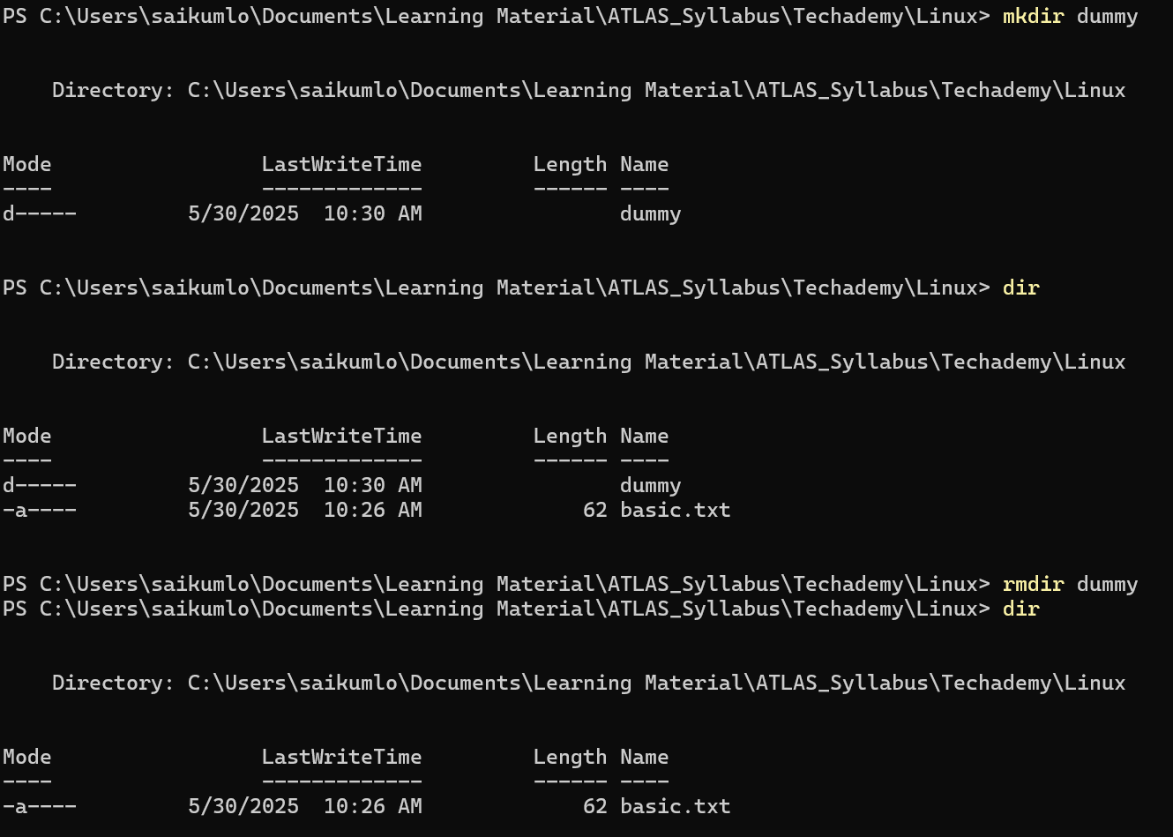

**Task5: Check working directory**

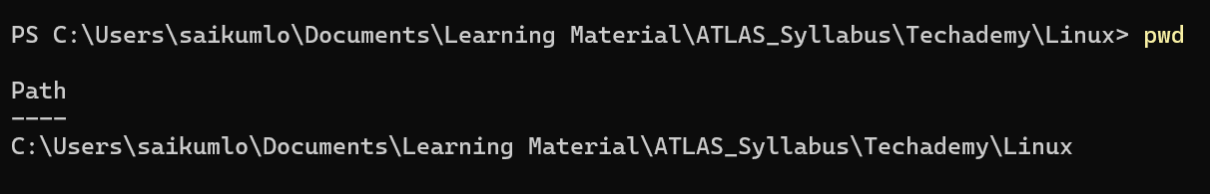

**Task6: Check files and directory**

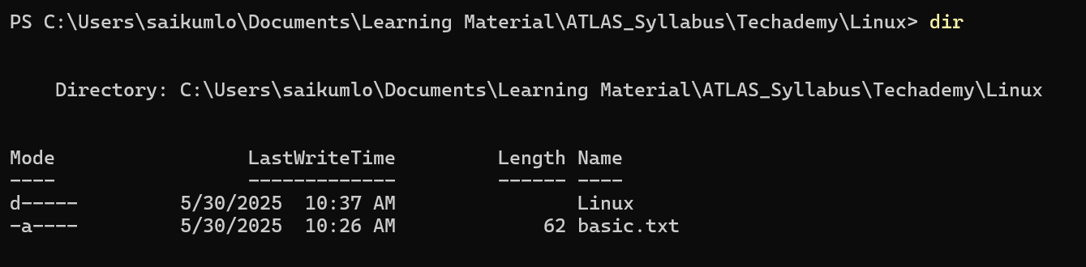

**Task7. Create 5 files**

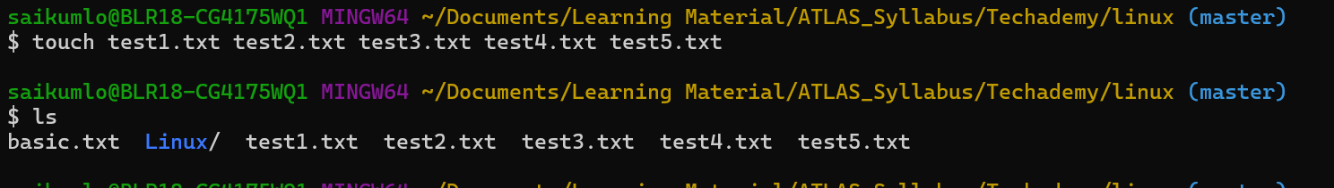

**Task8. Copy all files to diff directory**

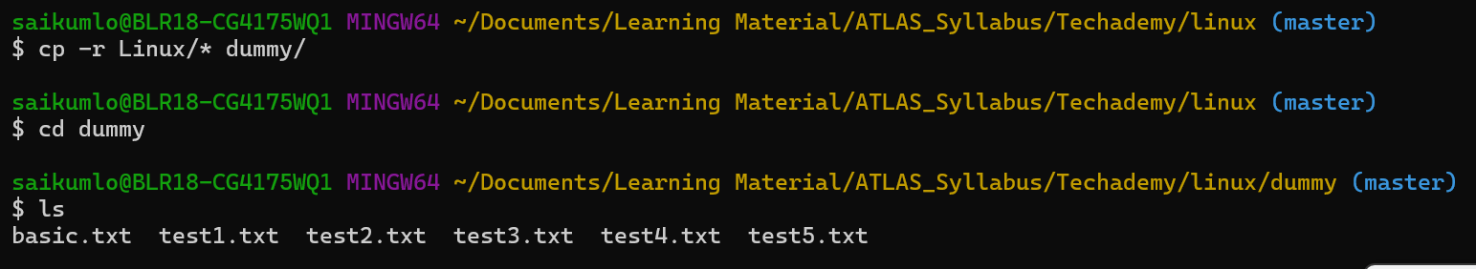

**Task9. Move all files to diff directory**





**Task10. Diff between rm and rmdir**

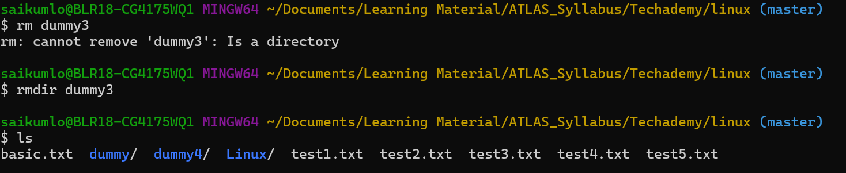

**Task11. Add text to file**



**Task12. Get top part of your file**

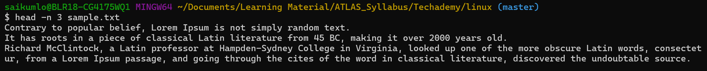

**Task13. Get tail part of the file**

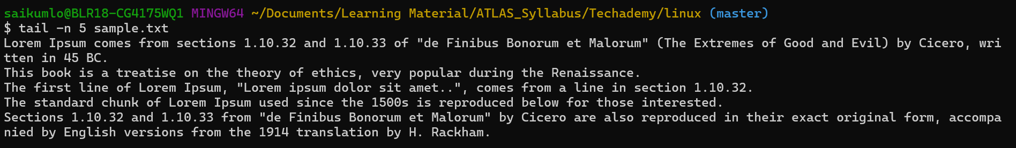

**Task14. Less command**



**Task15. more command**

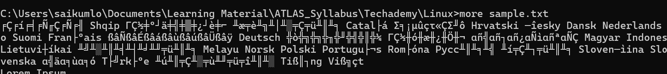

Difference between more and less

more: it gives simple view of data with forward scrolling

less: It supports data scrolling, page view and searching

**Task16. echo & echo -e**

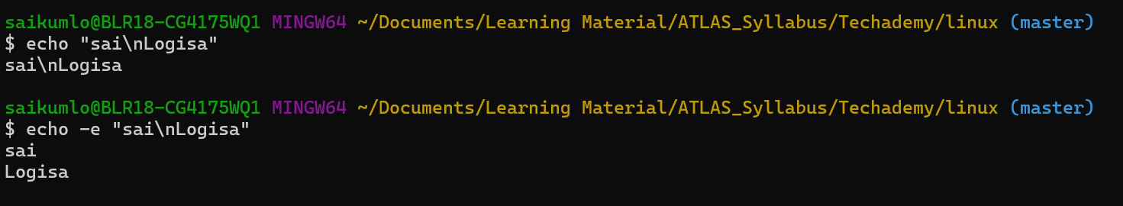

**Task17. Difference between ls & ls-l**

ls: list all the files and directories

ls -l: list all the files and directories with their detailed information such as r/w/x permission details, owner, modified time and the size details

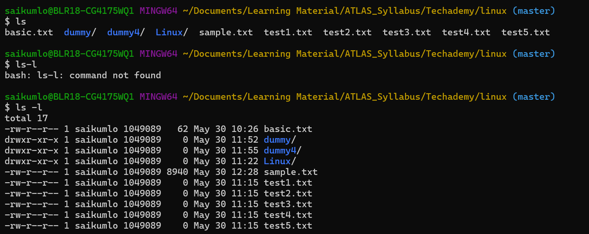

**Task18. Create a file using touch, cat, echo and mention the difference**

touch: creates an empty file

cat: creates file with user entered content

echo: creates file with provided text

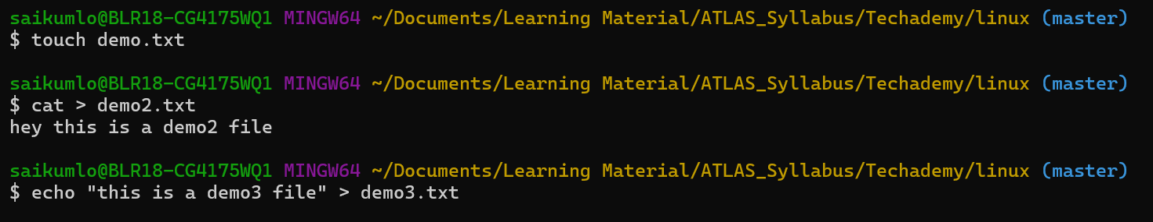

**Task19. Display the calendar**

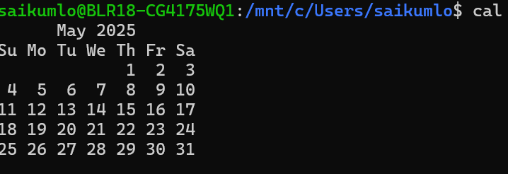

**Task20. Command to go back to one directory at a time**

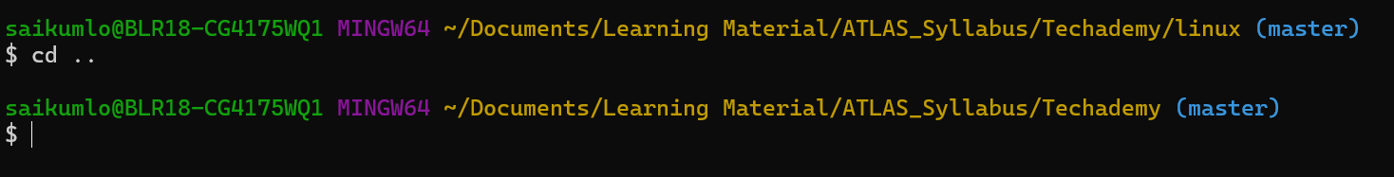

**Task21. Command to know which user is working**   


**Task22. Find who is peeping into the system**

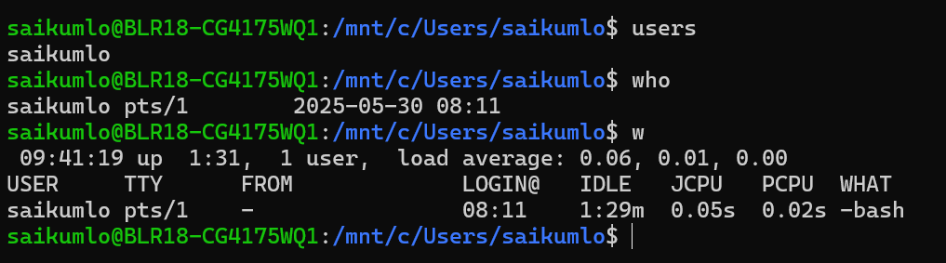

**Task23. Check disk space**

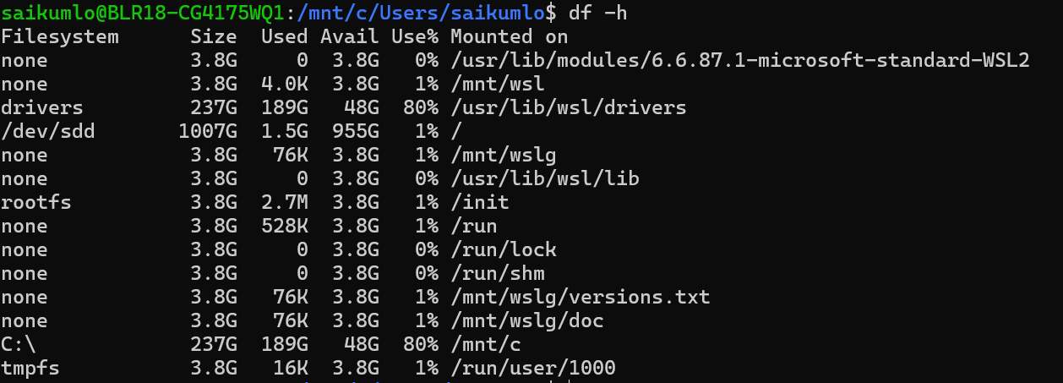

**Task24. ls command and its operations**

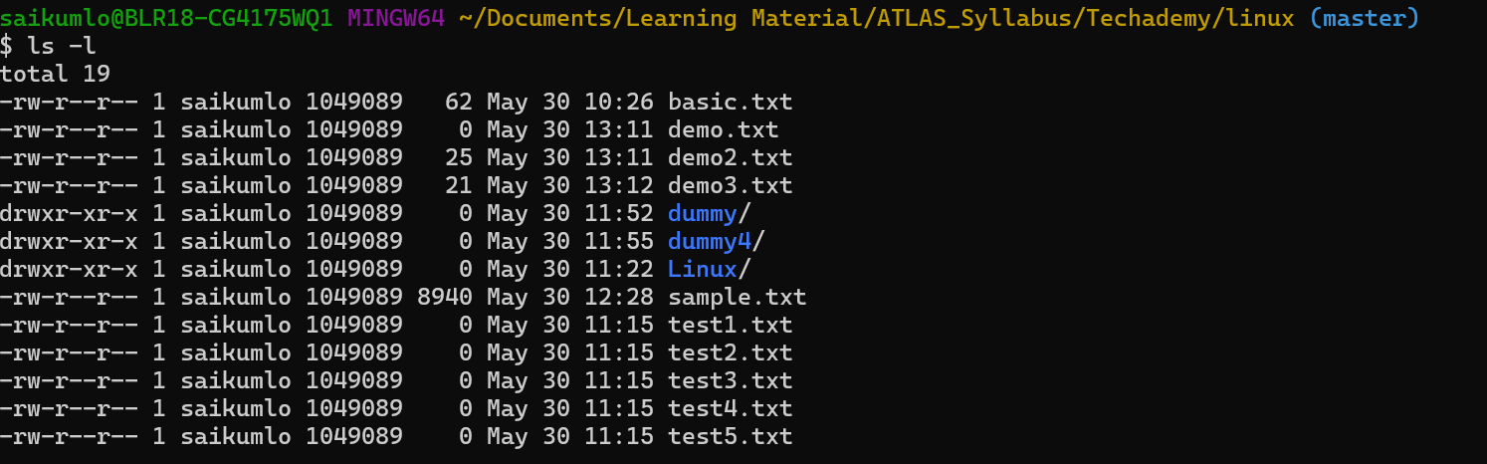

**Task25. find all files ending with .txt**



**Task26. Check all hidden files**



**Task27. Difference between . and ..**

. refers to current directory

.. refers to parent directory

**Task28. Create a file using vi editor and add text to it**



**Task29. word count of a file**



**Task30. What is the use of cat -b myfilename.txt command?**

cat: displays entire content

cat -b: displays non blank lines

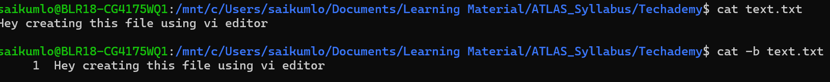

**Task31. Can we use the wc with 2 or more files?**

Yes, sample below



**Task32. Copy content from one file to another**



**Task33. Rename the file to Myfilenew**

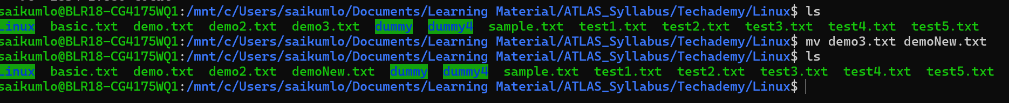

**Task34. Remove multiple files**



**Task35. Check what cd / is doing**

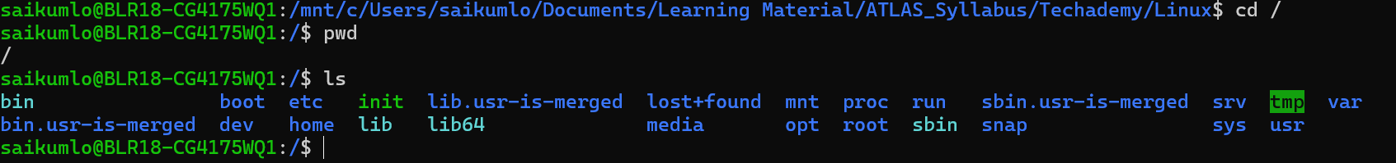

**Task36. Move to home directory**

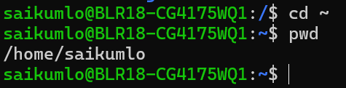

**Task37. Change to different user**

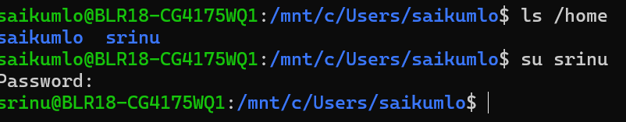

**Task38. Read about chmod**

Done